Virtual PAR ACCEPTance test PLAN document

Initial draft (April 20, 2005)

prepared by

vivek vaishampayan

VPAR Project – Feature – START-OF-FLASH PHASE

Feature description:

Start-of-flash phase will occur only after the verification of an incoming order based on the requirements stated in “Project Charter for Virtual PAR”. The order can be either NBBO Reject or Tweeners or Tweener Locks. The Flash process is similar to Auction an order, for very short duration of time, to the virtual crowd instead of routing to PAR.

Activity Diagram:

Please see the Activity Diagram below.

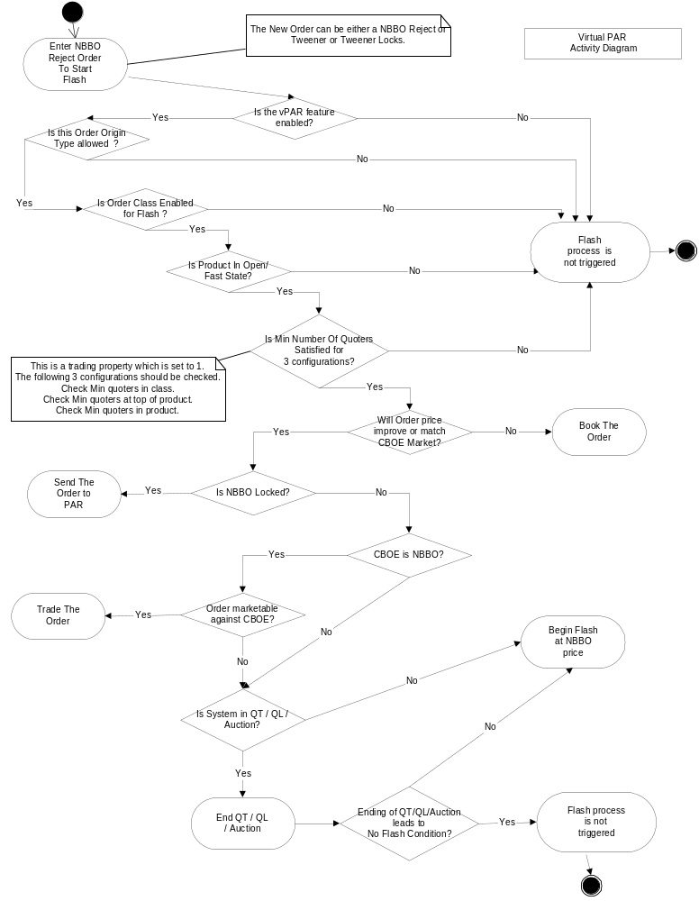
FEATURE DECISION TABLE (NOT COMPLETE BY ANY MEANS)

Decision Points |  |  |  |  |  |  |  | outcomes
Order Origin  Type Valid? | Order Class enabled  For Flash? | Product in  Open/fast state? | Min # of quoters?  (Three checks) | Order improves OR matches CBOE? | Is NBBO Locked? | CBOE = NBBO? | Order marketable against CBOE? | Flash The Order? | Comments?
Y | Y | Y | Y | Y | N | Y | Y |  | Trade it
Y | Y | Y | Y | Y | N | Y | N | √
Y | Y | Y | Y | Y | N | N | - | √
Y | Y | Y | Y | Y | Y | - | - |  | TO PAR
Y | Y | Y | Y | N | - | - | - |  | Book IT
N |  |  |  |  |  |  |  | No
Y | N |  |  |  |  |  |  | no
Y | Y | N |  |  |  |  |  | no
Y | Y | Y | N |  |  |  |  | no
Y | Y | Y | Y | Y | N | Y | N | no | end of QT/QL => no-flash
Y | Y | Y | Y | Y | N | N | - | NO | end of QT/QL => no-flash

vPAR Examples

Example #1:

1.00 – 1.20 100 x 100 NBBO
1.00 – 1.25 100 x 100 CBOE

Customer Order to Buy @ 1.25 x 50

Firm Quote stored for MM1

Auction starts, RFP sent to all MM quoting in class
(any price, any product in that class)

Buy 1.20 x 50

Configure “flash” (flash for 1 second)
(end all Quote Lock, Quote Trigger)

RFP comes back

Ends “flash”

Trading at UMA OR Routing back to PAR.

Example #2:

1.00 – 1.20 100 x 100 BOTR
1.00 – 1.25 100 x 100 CBOE

Customer Order to Buy @ 1.25 x 50

Configure “Flash” (flash for 1 sec)

End of flash

-- No auction & trade if CBOE is NBBO
-- Route away if no response
-- Route away if remaining quantity

Trade
S order at 1.20 or better

Quote Trigger

Offer moves to 1.20 (either I-Order, RFP Response or quote)

Contingencies

AON
NBBO Check
IOC
FOK

